**Project Documentation**

**1.INTRODUCTION**

**PROJECT TITTLE:** Cook Book

**TEAM ID**: NM2025TMID39321

**TEAM LEADER:**

**Name:** Sandhiya J

**Email:** [sandhiyajayaram656@gmail.com](mailto:sandhiyajayaram656@gmail.com)

**TEAM MEMBERS:**

**Name:** Divya Devi K

**Email:** [divyadevipop@gmail.com](mailto:divyadevipop@gmail.com)

**Name:** Rajeshwari R

**Email:** rrajeshwari2841@gmail.com

**Name:** Dhanushree S

**Email:** [srinivasandhanushree22@gmail.com](mailto:srinivasandhanushree22@gmail.com)

**2. PROJECT OVERVIEW**

**Purpose**:

Cookbook provides a collection of recipes and cooking techniques to guide

individuals in preparing a variety of dishes

**Features:**

* Recipes
* Cooking Techniques
* Ingredient Lists
* Measurements
* Tips and Variations
* Photographs
* Index

**3. ARCHITECTURE**

* **Frontend:** React.js with Bootstrap and Material UI
* **Backend:** Node.js and Express.js managing server logic and API endpoints
* **Database:** MongoDB stores user data, project information, applications, and chat messages

**4. SETUP INSTRUCTIONS**

**Prerequisites:**

* Node.js
* MongoDB
* Git
* React.js
* Express.js **–** Mongoose **–** Visual Studio Code

**Installation Steps:**

* Clone the repository git clone
* Install client dependencies cd client npm install
* Install server dependencies cd ../server npm install >public

**5. FOLDER STRUCTURE**

>node_modules

>src

App.css

App.js

App.test.js

index.css

index.js

logo.svg

reportWebVitals.js

setupTests.js

**6.RUNNING THE APPLICATION**

* **Frontend:** cd client npm start
* **Backend:** cd server npm start
* **Access:** Visit <http://localhost:3000>

**7. API DOCUMENTATION**

* **User:** 
  + /api/user/register
  + /api/user/login
* **Projects:** 
  + /api/projects/create
  + /api/projects/:id
* **Applications:**

/api/apply

* **Chats:**
* /api/chat/send
* /api/chat/:userId

**8. AUTHENTICATION**

* JWT-based authentication for secure login
* Middleware protects private routes

**9. USER INTERFACE**

* Landing Page
* Freelancer Dashboard
* Admin Panel
* Project Details Page

**10. TESTING**

* Manual testing during milestones
* **Tools**: Postman, Chrome Dev Tools

**11. SCREENSHOTS OR DEMO**

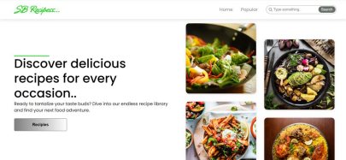

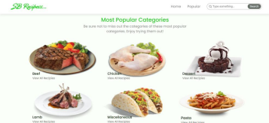

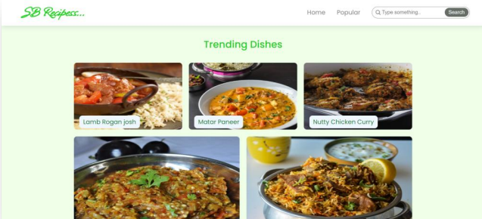

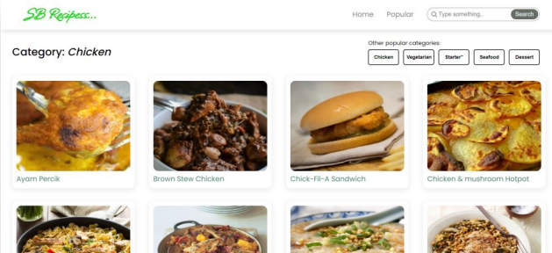

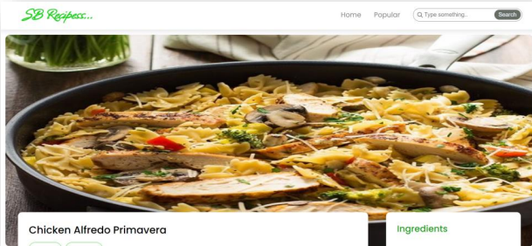

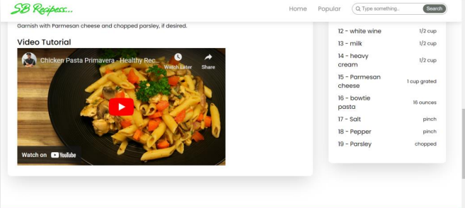

**12.FUTURE ENHANCEMENTS**

Future cookbook enhancements could include interactive digital features like videos and tutorials. Smart technology integration, such as meal planning and grocery lists, could also be added.